Experiment 10
Capture and analyse network packets using network Packet Analyzer

What is wireshark doing behind the scenes?
Wireshark uses you Network Interface Card (NIC) in a special mode to see all traffic – not just packets addressed to your device.
Wireshark gains some special permission through the NIC card and works in 2 modes:
1. Promiscuous Mode:
Normally your NIC ignores other devices packets. Wireshark enables Promiscuous Mode to capture all packets on the network segment.

2. Monitor Mode (Wireless)
On Wi-fi, Monitor Mode captures all wireless frames in the air – even those not meant for your device.

3. Libcap / ncap [Tools and Drivers]
Wireshark relies on libcap(Linux/Mac) or Ncap(Windows) to pull raw packets directly from OS Kernel.

Flow:
PC1, PC2 -> Libcap/Ncap [Fetches data from kernel] -> NIC -> Wireshark – Packet Sniffing

Protocols to capture:
1. HTTP / HTTPS
2. ARP
3. DHCP
4. DNS
5. ICMP
6. SSH / FTP

What are network interfaces?
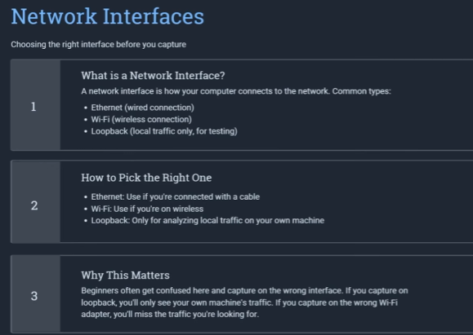

icmp && ip.addr == 8.8.8.8

ICMP Packet Capture Using Wireshark
Steps:
Step | What to do
1 | Connect your laptop to the Internet using Ethernet, Wi-Fi, or mobile hotspot.
2 | Open Wireshark.
3 | Select your active interface: Ethernet if using LAN cable, Wi-Fi if using hotspot/Wi-Fi.
4 | Double-click the interface to start packet capture.
5 | Keep Wireshark capturing. Do not stop it.
6 | Now open Command Prompt (CMD).
7 | Run ping 8.8.8.8
8 | Wait until the ping command finishes.
9 | Return to Wireshark.
10 | Click the red Stop button to stop capturing.
11 | Apply the filter icmp && ip.addr == 8.8.8.8
12 | Identify the Echo Request and corresponding Echo Reply.

Ethernet Header = 14 bytes
IPv4 Header = 20 bytes
ICMP Header = 8 bytes
Ping Data = 32 bytes
-------------------------
Total = 74 bytes
ARP Packet Capture Using Wireshark
Steps:
Step | What to do
1 | Connect your laptop to Ethernet/Wi-Fi/mobile hotspot.
2 | Open CMD first.
3 | Run ipconfig and note the Default Gateway IP.
4 | Open Command Prompt as Administrator.
5 | Run arp -d * to clear dynamic ARP cache entries for a clean demonstration.
6 | Now open Wireshark.
7 | Select the active Ethernet or Wi-Fi interface.
8 | Start packet capture.
9 | Keep Wireshark capturing and return to CMD.
10 | Run ping <Default-Gateway-IP> — for example, ping 192.168.0.1.
11 | After ping finishes, return to Wireshark.
12 | Click the red Stop button.
13 | Apply the Wireshark filter arp.
14 | Find the ARP Request and corresponding ARP Reply.
15 | Analyze Source, Destination, Length, Info, Sender IP/MAC and Target IP/MAC.

DNS Packet Capture Using Wireshark
Steps:
Step | What to do
1 | Connect the laptop to the Internet using Ethernet/Wi-Fi/mobile hotspot.
2 | Open Wireshark first.
3 | Select the active Ethernet or Wi-Fi interface.
4 | Start packet capture.
5 | Keep Wireshark capturing.
6 | Now open CMD.
7 | Run nslookup example.com
8 | Wait for the DNS result to appear in CMD.
9 | Return to Wireshark.
10 | Click the red Stop button.
11 | Apply the filter dns.qry.name == "example.com"
12 | Identify the A Query and its Response.
13 | Analyze Source, Destination, Protocol, Length and Info.
14 | Click the packets and inspect the DNS and UDP fields.

TCP Packet Capture Using Wireshark
Steps:
Step | What to do
1 | Connect laptop to Internet using Ethernet/Wi-Fi/mobile hotspot.
2 | Open Wireshark first.
3 | Select the active Ethernet or Wi-Fi interface.
4 | Start packet capture.
5 | Keep Wireshark capturing.
6 | Now open CMD.
7 | Run curl http://example.com
8 | Wait until the command finishes and HTML/output appears.
9 | Return to Wireshark.
10 | Click the red Stop button.
11 | Apply filter tcp.port == 80
12 | Find the TCP connection generated for example.com.
13 | Identify [SYN] → [SYN, ACK] → [ACK].
14 | Examine Source, Destination, Ports, Sequence/Acknowledgment numbers and Flags.
15 | Optionally use Follow → TCP Stream to show HTTP GET and 200 OK.

